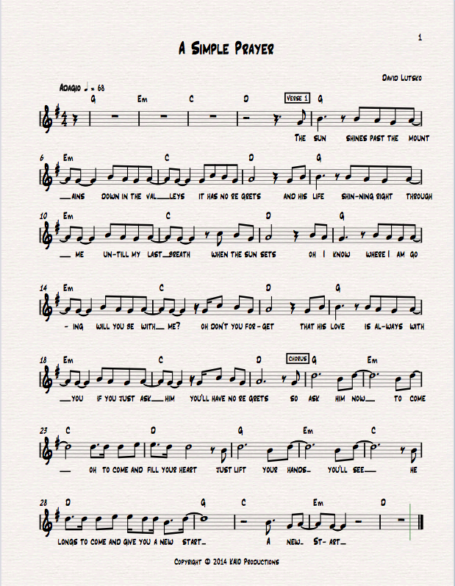

2

VERSE 2
Cause He came into this world for you
Hung on the cross for you
Gave up his life
Willingly, will you accept Him?
Will you just lay down
Your sacrifice?
Cus’ He knows what you are going through
What seems to harm you
He’ll use for good
If you just say, “Lord here I am
Please come and use me
Come if You would.”

CHORUS
So ask Him now
To come, oh come and fill your heart
Just lift your hands
You’ll see
He longs to came and give you a new start

BRIDGE
F#m D
A simple prayer is all He wants
F#m E
A simple prayer is all you need

CHORUS x2
So ask Him now
To come, oh come and fill your heart
Just lift your hands
You’ll see
He longs to came and give you a new start
So ask Him now
To come, oh come and fill your heart
Just lift your hands
You’ll see
He longs to came and give you a new start

